**ASSIGNMRNT 4**

|  |  |
| --- | --- |
| Date | 31October2022 |
| TeamID | PNT2022TMID40997 |
| MaximumMarks | 2Marks |

**Question1:**

*Write code and connections in wokwi for the ultrasonic sensor.

*Write code and connections in work for ultrasonic sensor.Whenever distance is less than 100cms send"alert"to ibm cloud and display in device recent events.

**Code:**

#define ECHO_PIN 1

#define TRIG_PIN 9

void setup() {

**Serial**.begin(115200);

pinMode(LED_BUILTIN, OUTPUT);

pinMode(TRIG_PIN, OUTPUT);

pinMode(ECHO_PIN, INPUT);

}

float readDistanceCM() {

digitalWrite(TRIG_PIN, LOW);

delayMicroseconds(2);

digitalWrite(TRIG_PIN, HIGH);

delayMicroseconds(10);

digitalWrite(TRIG_PIN, LOW);

int duration = pulseIn(ECHO_PIN, HIGH);

return duration * 5.044/2;

}

void loop() {

float distance = readDistanceCM();

bool isNearby = distance < 100;

digitalWrite(LED_BUILTIN, isNearby);

**Serial**.print("Measured distance: ");

**Serial**.println(readDistanceCM());

 delay(100);

}

WOKWI LINK : https://wokwi.com/projects/347102827413242450

**Solution :**



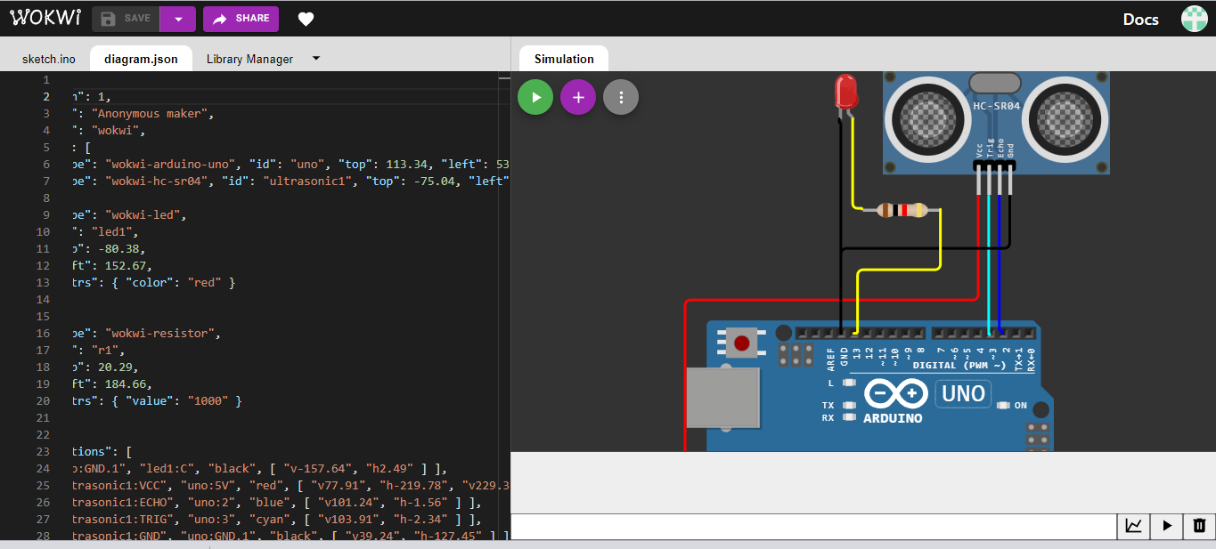

**Solution run:**

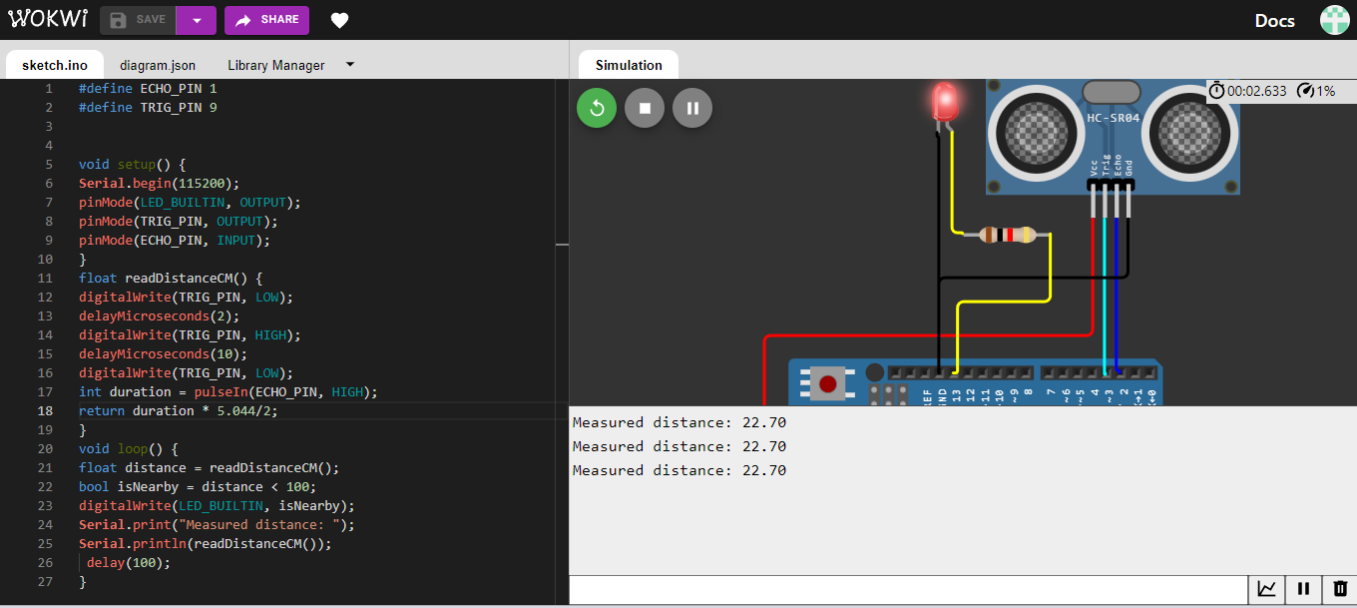

OUTPUT:

DATA IS SENT TO IBM CLOUD WHEN NO OBJECT IS DETECTED

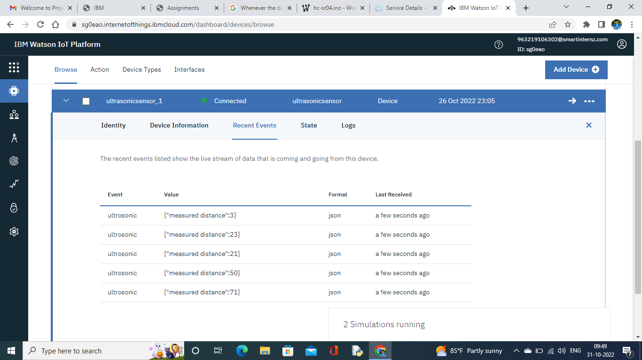

When no object is detected :

